UW RGB Colour.wmf

**Department of Mechatronics Engineering**

**Lab 2 Report – Extended Kalman Filter**

**A Report Prepared For:**

Professor Arami

**Prepared By:**

William Ancich

Austin Milne

Jude Bennett

March 02, 2024

# Extended Kalman Filter Formulation

## State Vector

The state vector that was implemented for this system was the following:

## Linear Motion Model

## Model

The following linear motion model was defined:

## Time Step

A time step of T=0.05 was selected for the Kalman filter as this was the measurement interval of the sensors.

## Model Matrices

The A matrix for this model is:

The Q matrix for this model was selected to be the following:

These values were determined experimentally by analyzing the filtered results and selecting values that resulted in a curve most closely resembling the simulated displacement plot.

## Sensor Configuration

## Sensors

This execution of the lab utilized two infrared distance sensors. They were mounted vertically in line with one another approximately 4cm above the surface of the table. The medium and long-range sensors were selected as they had the largest overlapping effective range of 60cm, with a combined limit of 20cm and 80cm.

## Required States

Given that there are three states present in the motion model and measurements are only taken with regards to the first, distance, at least 4 measurements are required in order to provide an accurate estimate of all three states.

## Setup Diagram

Figure 1: Sensor apparatus setup

# Simulation Implementation

The simulation system was implemented as outlined in the lab manual [1]. A basic kinematic motion profile is generated and altered with noise. The position is then converted to a sensor reading using the sensor profiles created in lab 1.

Sensor noise was calculated data gathered in lab. A constant noise parameter was used for each sensor equal to the average of sensor noise across its respective operating range. A value of 0.012409 was used for the long-range sensor, and 0.010606 was used for the medium-range sensor. The sensor fusion layer before the extended Kalman filter was implemented as a basic Bayesian averaging, using the above listed noise values.

Figure 2: Simulation Data Flow [1]

Once fused, the data was run through the extended Kalman filter. Tuning was performed to minimize error across the various simulated movement profiles.

## 2.1 Sensor Model Validation

Once the sensor models where created for the simulations, it was important to ensure that they operated as expected. Firstly, the static measurements of the sensors where compared to static readings from the simulated sensors. Additional data was collected during the lab to ensure these comparisons could be made against the sensors used for this experimental data.

|  |  |
| --- | --- |
|  |  |
|  | |

Figure 3: Static Sensor Comparison

Viewing the graphs, it is clear that there is a slight offset with both the long-range and medium-range sensors. This error, maxing out at 0.2 volts with the Long-Range sensor at 20cm, is primarily attributed to variations between individual sensors. For the purposes of this lab, this issue is reasonably negligible. Another thing to note with the simulated readings is that they have a more uniform noise profile across the signal band. Of note is how the noise between the generated and experimental data is very similar at 20cm, but the generated profile is noisier at 50 and 80cm. This is due to how the noise is modeled as constant across the range, but at the voltage level, not the range level. This means that the noise is exacerbated at longer ranges due to the conversion formula. Next, the simulated sensors were tested against the movement profiles. The below figure shows the data from a linear movement, both simulated and experimental.

Figure 4: Linear Motion Sensor Comparison

Readdressing the issue of sensor reading offset, it is evident that the variation from sensor to sensor is relatively minimal. While there is an offset at the end of the movement of almost 0.25 volts, this error translates to a difference of only around a few centimeters. With the purpose of these simulated sensors being to imitate the performance and profile of the sensors such that the applied filter can be tuned, these minimal errors should be problematic. The more important detail is the noise of the simulated sensors. As seen in the static measurements, the noise is highly representative at short distances, and over-exaggerated at longer distances. The change in Y-Axis scale between the graphs of static and dynamic measurements is of note. The static graphs show a closer view of the difference in noise, while the dynamic graph makes it difficult to notice a significant difference.

# Simulation

## Initial Estimate

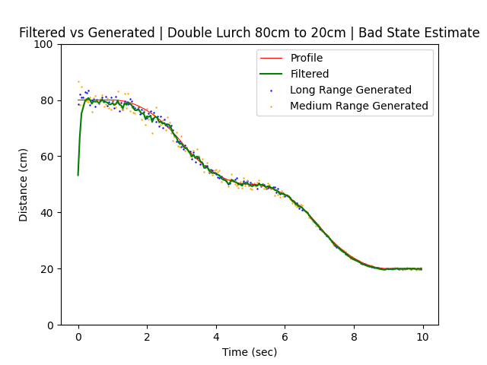

Figure 5: Poor initial estimate

The plot above shows a displacement profile for a motion for two distinct accelerations in one direction. The initial distance of this motion was 80cm. However, for this plot, the initial estimate given to the Kalman filter was 50cm. The effect of this poor estimate can be seen on the green, filtered line. The initial Kalman state output is nearly 30cm below what the first observed distance would have been. It does quickly reach the correct distance within the next few time steps and maintains an accurate fusion of the two sensors for the remainder of the motion.

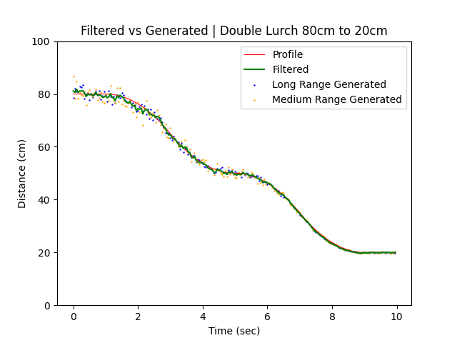

Figure 6: Good initial estimate

Figure 6 shows a plot of the same filtered motion but with the initial Kalman state correctly estimated to 80cm. From the figure it can be seen that the low, initial estimate present in Figure 5 is not present in Figure 6. A good initial estimate ensures that the Kalman filter is able to accurately fuse the collected data from the very beginning.

## Sensor Noise

The generated system model provided sensor noise covariances in the matrix shown below:

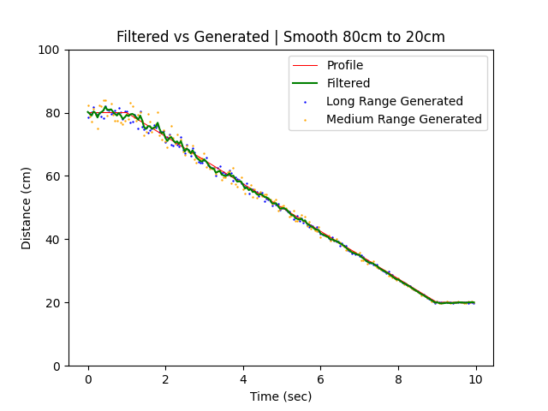

Figure 7: Constant velocity with model noise covariance

Figure 7 shows the filtered states for the correct sensor noise covariances.

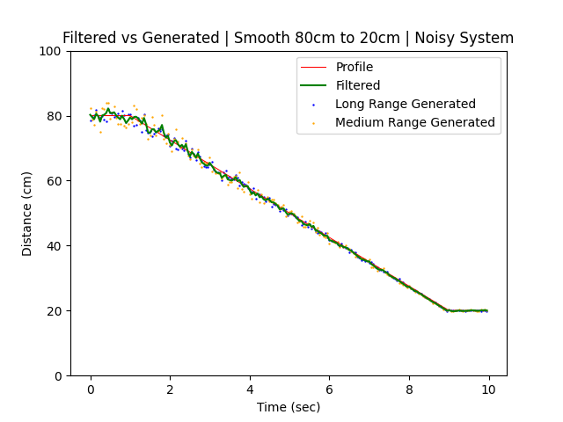

Figure 8: Constant velocity motion with increased noise covariance

Figure 8 shows the filtered states when the sensor noise covariances have been increased by a factor of 10. The increased noise appears to have had little effect on the state estimates, though the filtered line in Figure 7 does appear to be smoother overall than the filtered line in Figure 8.

## System Noise

Figure 9: Deceleration motion with process model noise

Figure 9 shows the filtered states on a motion consisting of a constant deceleration towards the final goal. This filter employed the Q matrix shown in Part 1.

Figure 10: Deceleration motion with increased process model noise

Figure 10 shows the filtered states on the same motion but with the following Q matrix:

With each element increased by a factor of 100. The plotted filtered states are noticeably rougher in Figure 10 compared to Figure 9, especially in the linear area and the area between times 2.5 and 6 where the deceleration becomes lower. There is no noticeable difference between the two plots towards the end of the motion.

## Experimental Motions



Figure 11: Constant velocity motion

The constant velocity motion fit the motion model very well since it kept acceleration constant at 0 m/s2. The filter fits the expected motion profile reasonably well in the first half of the motion and near perfectly in the second half.

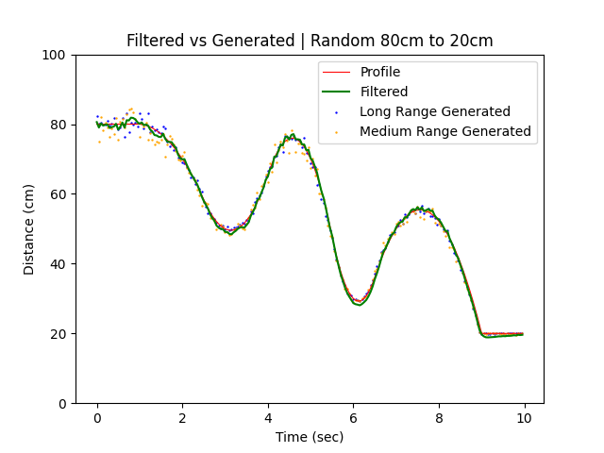

Figure 12: Random motion

The random motion was not a suitable fit for the motion model due to the numerous changes in acceleration. The motion model assumed that acceleration would be constant between time steps so the system could not accurately predict acceleration between time steps. Despite this, the filter was able to fuse the measurements fairly well. Though at the sharper peaks, indicating extreme changes in acceleration, the filter states diverge from the motion profile. This is an expected result given the situation regarding dynamic acceleration mentioned above.

Figure 13: Stationary object at 50cm

Like the constant velocity motion, the motion model developed would function properly with a stationary object. The plot of the filter states matches the motion profile very well with just a few deviations from the noisier regions of the simulated data.

# EKF Evaluation

Figure 14: Constant velocity motion with experimental data

In Figure 14, featuring experimental data, the measured distance between the long and medium range sensors differed significantly. The overall slope of the filtered states appears steeper than the generated motion profile, indicating that the aluminum was moved slightly faster than the simulation. At the end of the motion, where the measurements converge, the final distance is estimated to be approximately 22.3cm, above the actual final distance. This indicates that the sensor models were not calibrated perfectly, resulting in inaccurate readings. Compared to the simulated data, the result with the experimental data is far less accurate.

Figure 15: Random motion with experimental data

In Figure 15, the filter fuses experimental data for a random motion. The measurements diverge at the initial stationary segment, as well as at the peaks where there are shifts in acceleration. Here too, the final value rests above the true 20cm measurement.

Figure 16: Stationary object with experimental data at 50cm

Figure 16 demonstrates conclusively that at larger distances, there is a significant discrepancy between the measurements of the two sensors. This again indicates a deficiency in the sensor models. As a result, the filter struggles to fuse the data to a steady state. The result is an inconsistent prediction line that consistently predicts too large distances. The result is less accurate than with the simulated data, which offered a more consistent base for the filter.

# References

|  |  |
| --- | --- |
| [1] | A. Arami, L. E. Tang, M. Shushtari and E. Tahvilian, "Lab 2 – Sensor Fusion with EKF," University of Waterloo - Department of Mechanical and Mechatronics Engineering, Waterloo Ontario, 2023. |